Modelling Of Software

Intensive Systems

Assignment 1: Modelica

1st Master computer science

2024-2025

Liam Leirs

Robbe Teughels

# Plant Model Creation:

We created a model of a plant that has a trolly with a rope attached to it. The goal of this model is to evaluate both the pendulum and the trolly. More specific, the (angular) speed and the displacement. This can be tuned by the Damping factors *Dp* and *Dc*. For controlling the model, we use the control signal *u* that gives the desired displacement.

We tested the model with two intuitive tests: no displacement, set displacement.  
When we require the cart to stay fixed in place, the entire model stays fixed as we would expect. When we set the control system to a desired location, we see the cart move to the exact location, given some time. The pendulum reacts on the movement of the cart as required. Given these tests, we assume that the model is representative to the real object for velocity and displacement.

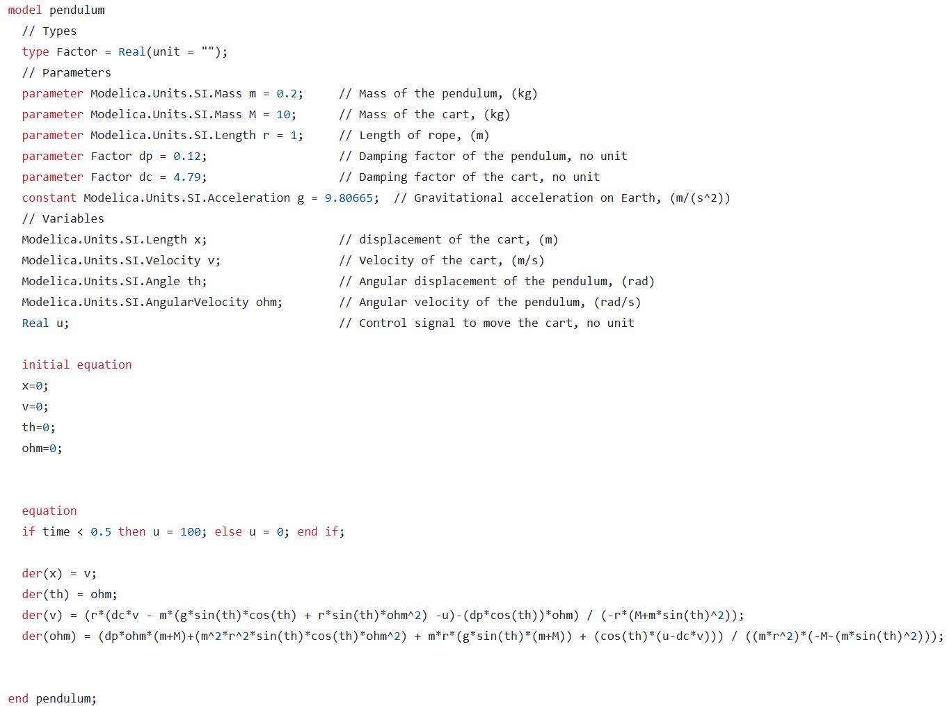

# Plant Model Calibration

Now that the plant model was created, it still needed to be calibrated (via the damping factors Dp & Dc). To do this, 2 new models had to be created where the effects of one of these factors is eliminated allowing us to estimate the other one.

For estimating Dc we will “lock” the pendulum essentially reeling it in:

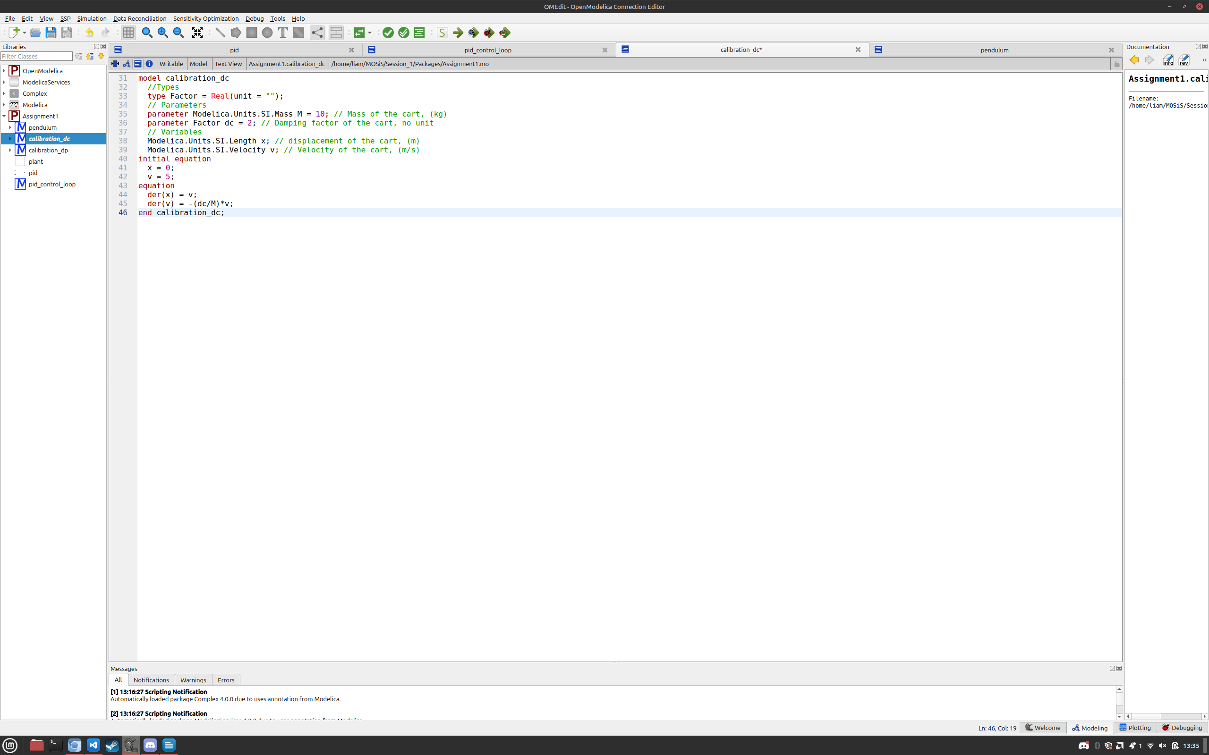

For estimating Dp the trolley’s movement will be locked:

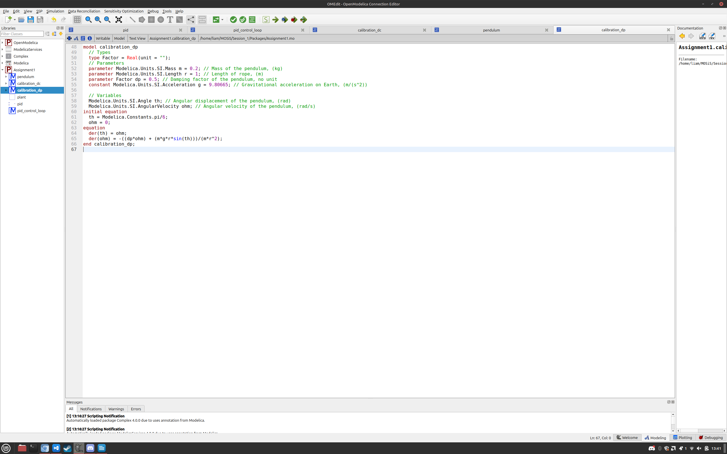

To calibrate these factors, we will use a collection of real-life measured data to compare our simulated data to. The damping coefficient Dp & Dc can take on values in the interval (0, 5] (precise up to 2 decimals). For each possible value the model will be simulated compared to the real-life data by calculating the sum of squared errors. The simulation with the smallest error will be the best one.

Code for tuning the parameters (parameter_tuning.py):  
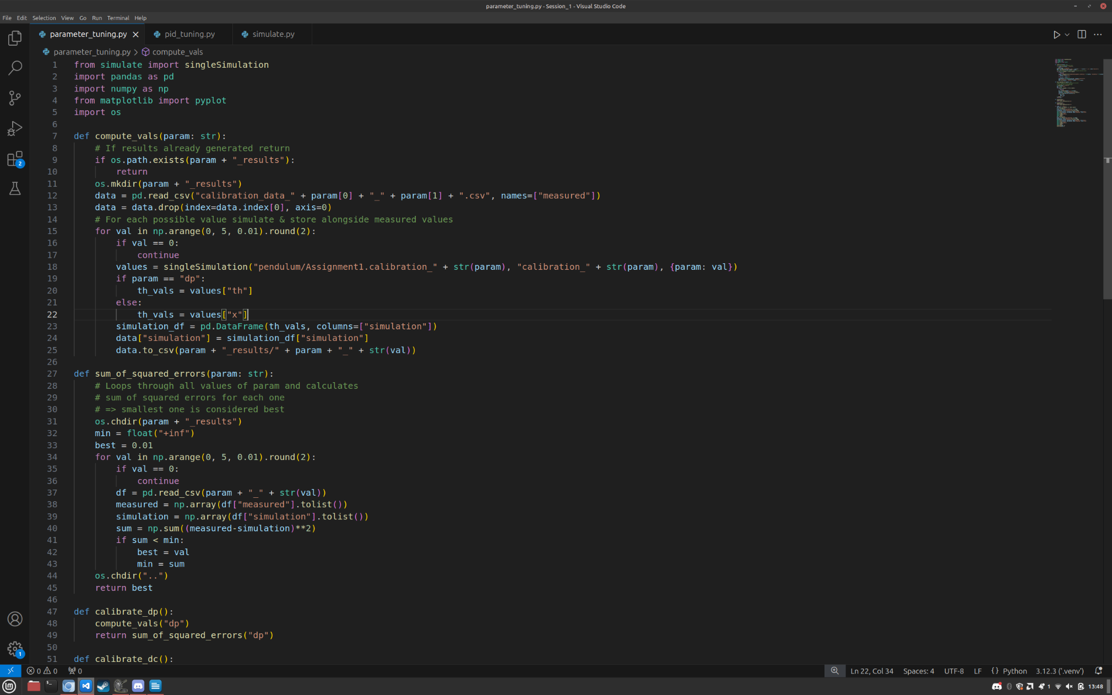

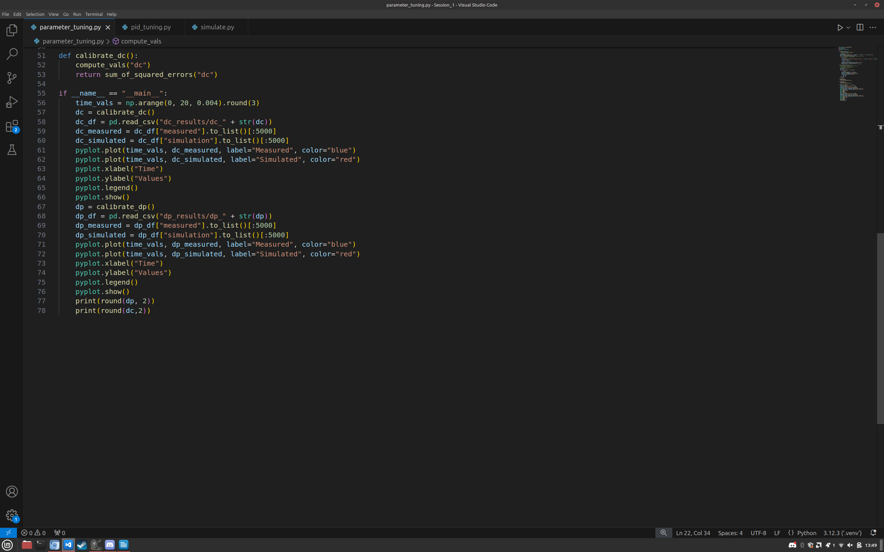

The above code gave the values 0.12 for Dp and 4.79 for Dc. Plotting the simulation data alongside the measured data for these values generates the following plots:

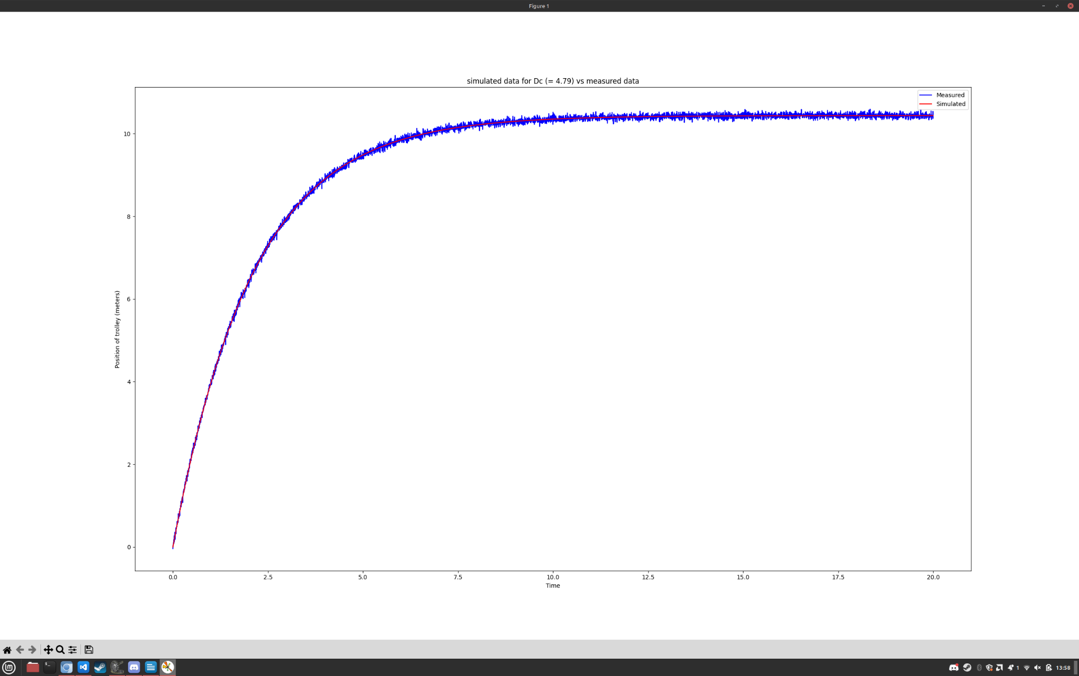

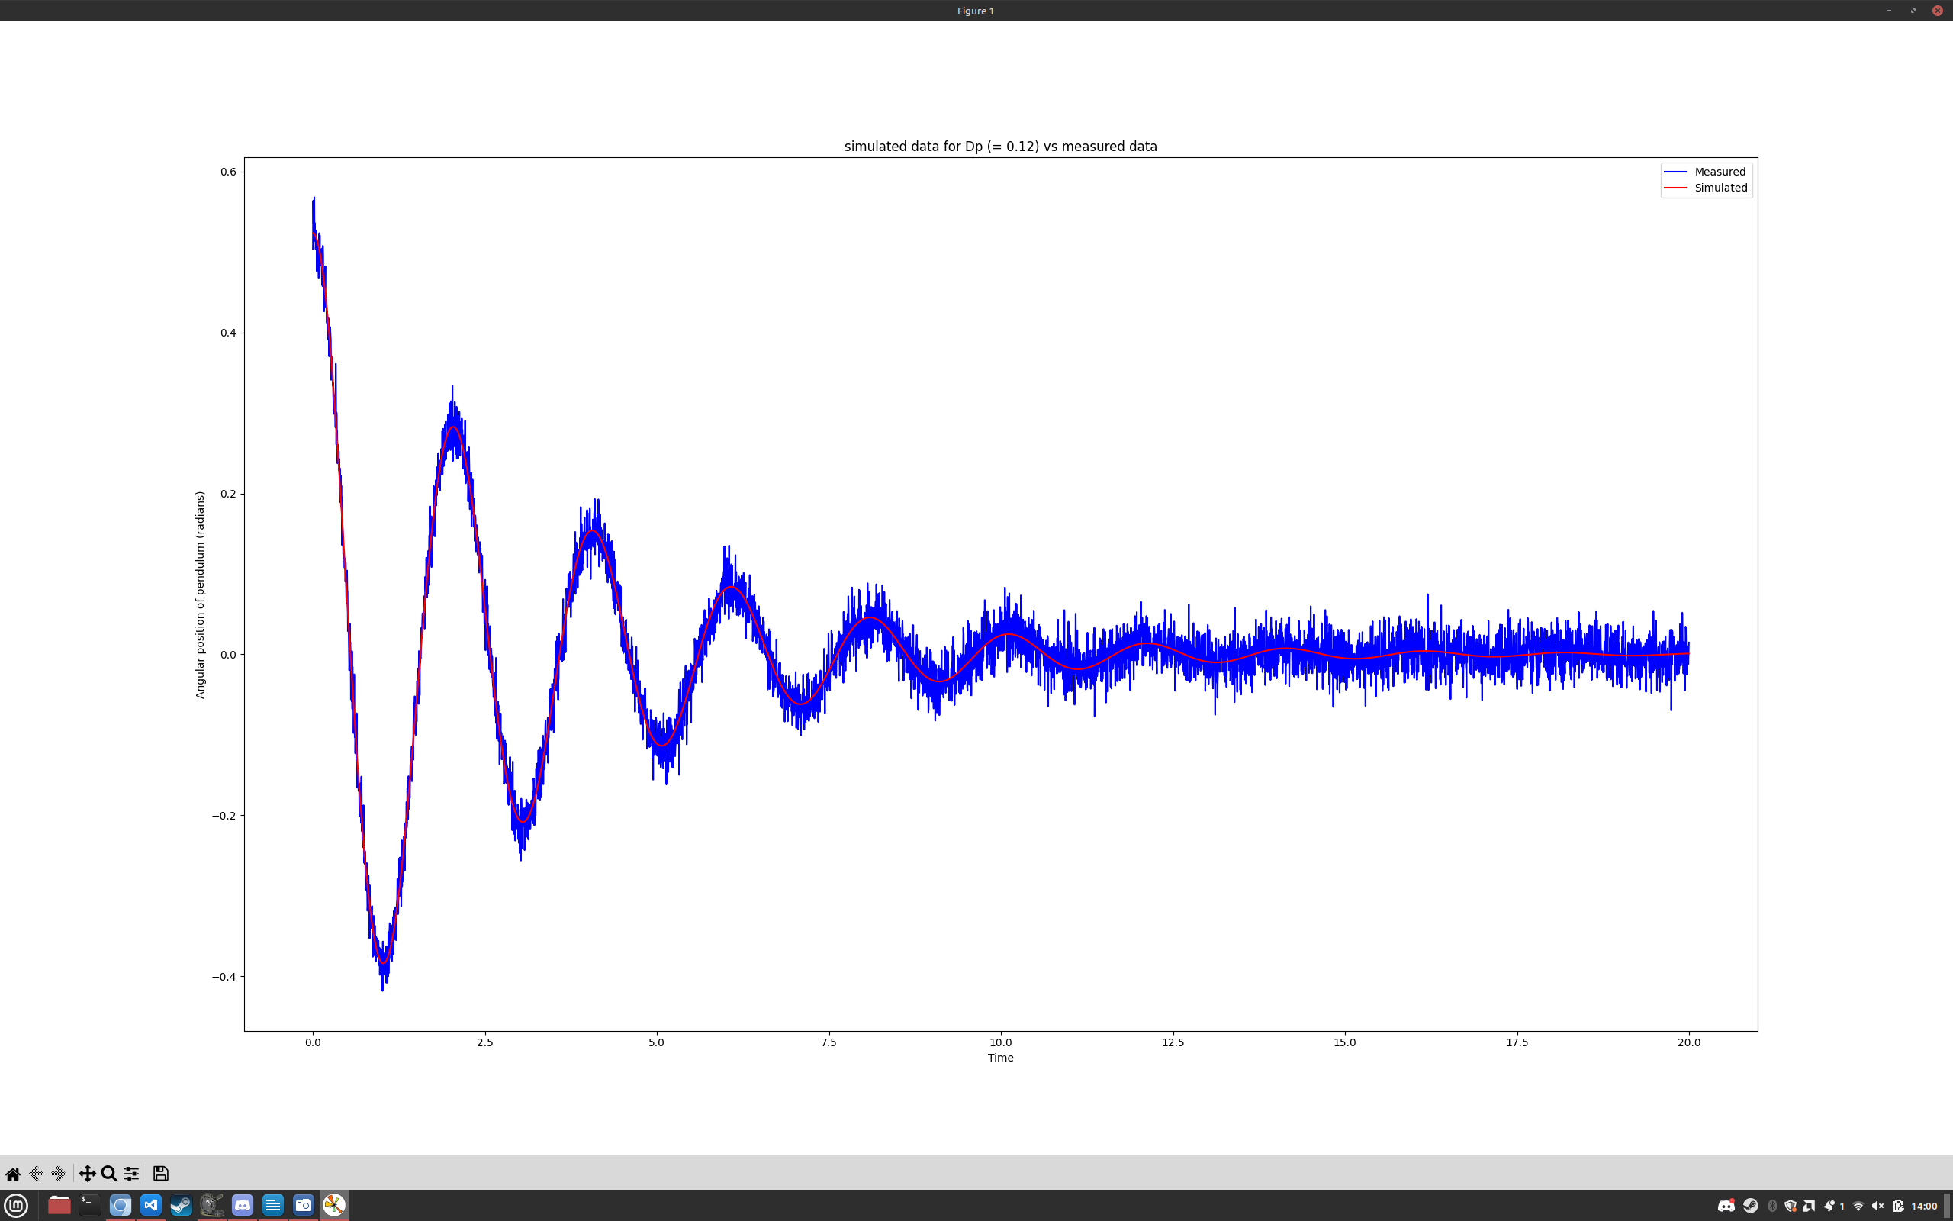

# Controller Model Creation

Our final goal is to make a controller for the physical plant. We can use our finetuned plant and contain it within a block for a simple interface with in and puts that we also have in the real plant.

Our controlees will be a PID-controller. We define the core of the controller as a block so its ready for later. It will use the desired displacement of the plant and the actual displacement to smoothen/optimize the movement.

We have all our blocks ready to create a fully functional plant. By connecting the plant and the controller with the right in and outputs we have a controller controlling the plant. We can change the behavior of the controller by Kp, Ki, Kd of the PID-controller.

Kp:

This variable determines how much the controller reacts to the error. High values

make the controller more responsive and aggressive resulting in overshooting. Low values at the other hand may take more time to reach the destination and takes even longer to make the final adjustments to the exact location.

Ki:

By remembering past errors, we can increase accuracy. High values results can cause overshooting and creates oscillations in the control system that can make the system unstable. Low values will result in a more stable system and better settling times.

Kd:

By predicting future errors, we can add a damping effect. High values will reduce overshoots and improve settling time at the cost of a less responsive controller. Low values will result in a less stable system with more overshoots and oscillations.

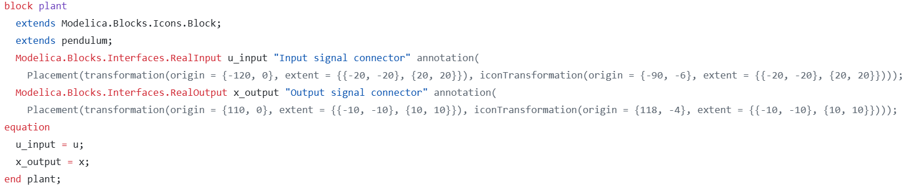

Block of Plant

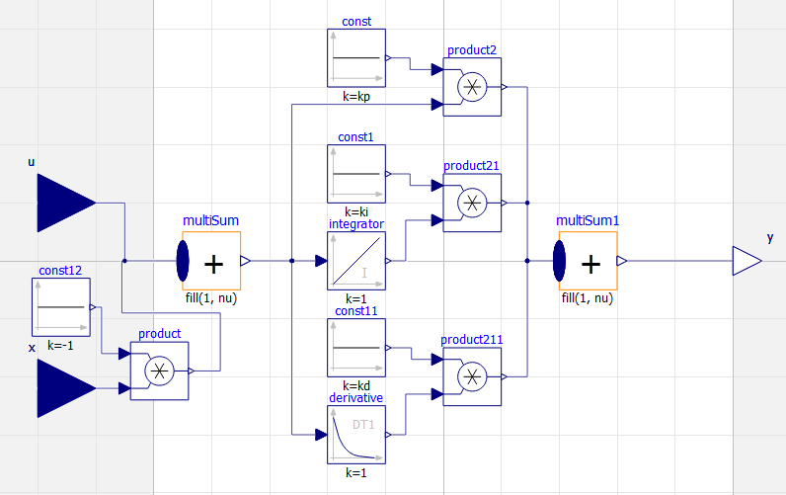

PID controller

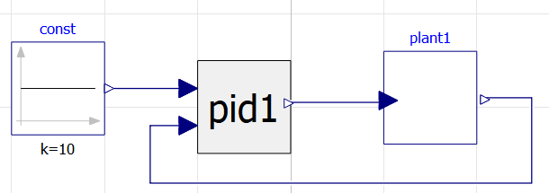

PID-control loop

# Controller Model Tuning

Now that we have a model for the pid controller and the control loop, it’s time to calibrate it to find the optimal values for Kp, Ki & Kd using the cost function a*th_max + b*t_task where th_max is the maximum angular displacement of the pendulum and t_task is the moment when the gantry reaches the desired set-point of 10 meters (with 10 cm accuracy thus reaching 9.9 meters) and the pendulum's angular displacement remains within the acceptable range of 10 degrees.

Using this cost function it’s clear that a PD controller will suffice thus Ki will be 0. The values for a & b are weight coefficients based on the student ID. Plugging the last four digits of our student ID’s (1127 & 0395) into the provided python script we got the values 15 for a & 22 for b.

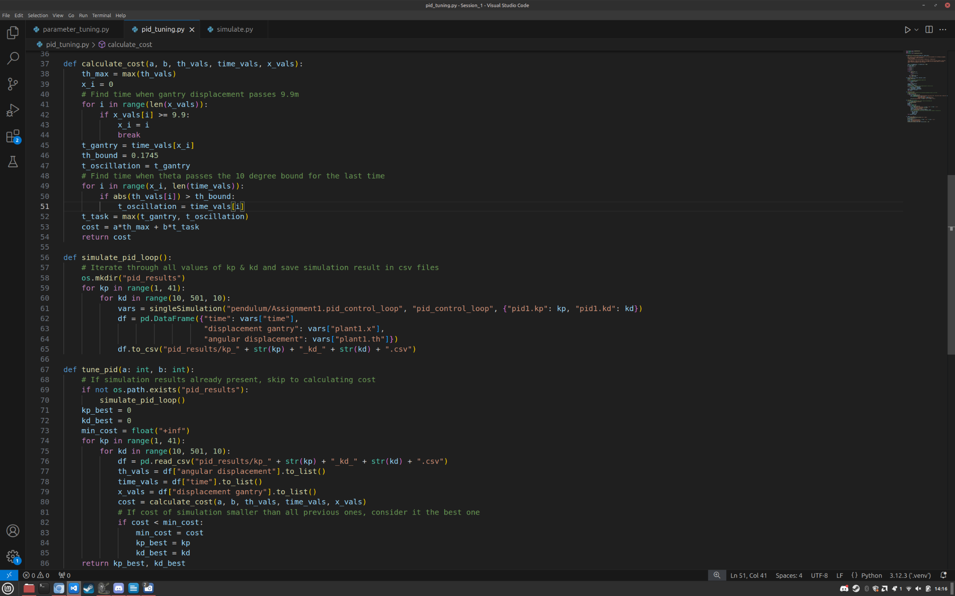Code for finding values with lowest cost:

Executing the script above gave us the optimal values 7 for Kp and 10 for Kd.

Simulating again with these values gives the following plot:

